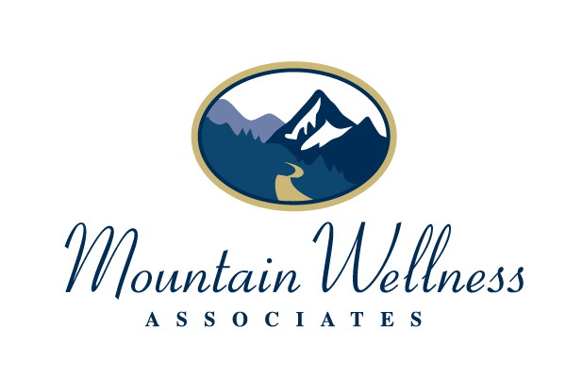

INFORMED CONSENT FOR IN-PERSON SERVICES DURING COVID-19 PUBLIC HEALTH CRISIS

This document contains important information about the decision to conduct in-person services in light of the COVID-19 public health crisis. Please read this carefully and let your therapist know if you have any questions. When you sign this document, it will be an official agreement.

Decision to Meet Face-to-Face
We have agreed to meet in person for some or all future sessions. Reasons for taking this risk include but may not be limited to client safety risk factors, the importance of in-person clinical observations to determine appropriateness for ongoing Telehealth services, and Telehealth best practices. If there is a resurgence of the pandemic or if other health concerns arise, however, your therapist may require that meetings occur via telehealth. If you have concerns about meeting through telehealth, please share them with your therapist to address any issues.

Please know that should you decide at any time that you would feel safer staying with, or returning to, telehealth services, that decision will be respected. Should there be any clinical concerns regarding transitioning away from in-person services, your therapist will review these with you. Given that insurance companies and applicable laws/governmental orders impact the delivery of telehealth services in a variety of ways, our decisions may be impacted by these and warrant ongoing discussion.

Risks of Opting for In-Person Services
You understand that by coming to the office, you are assuming the risk of exposure to the coronavirus (or other public health risk). This risk may increase if you travel by public transportation, cab, or ridesharing service.

Your Responsibility to Minimize Your Exposure
To obtain services in person, you agree to take certain precautions which will help keep everyone (you, your therapist, families, and other providers and clients at 155 Washington St.) safer from exposure, sickness and possible death. If you do not adhere to these safeguards, it may result in our starting / returning to a telehealth arrangement. Initial each to indicate that you understand and agree to these actions:
- You will only keep your in-person appointment if you are symptom free. ___
- You will take your temperature before coming to each appointment. If it is elevated (100 Fahrenheit or more), or if you have other symptoms of the coronavirus (i.e. cough, loss of smell or taste, sore throat, or shortness of breath), you agree to cancel the appointment or proceed using telehealth. Should you not take your temperature prior to coming in for your appointment, you will be given the option of rescheduling or having your therapist take your temperature with an infrared thermometer. If you need to cancel for this reason, even on the same day as the appointment, the late cancellation/no-show fee will be waived. __
- You will wait in your car or outside until no earlier than 5 minutes before your appointment time. ___
- You will complete any relevant intake paperwork prior to your arrival to our office space. ___
- You will wash your hands or use alcohol-based hand sanitizer when you enter the reception area or your therapists office. ___
- You will maintain social distancing in the reception area. ___
- You will wear a mask into the building and in the reception areas. The decision regarding wearing masks during your therapy session will be determined by you and your therapist. ___
- Although it is customary to greet one another with a handshake, during this time you will agree to refrain from any physical contact with your therapist. ___
- Although at normal times clients need to bring children to the session and have them wait in the reception area, during this time you agree not to & you’ll contact your therapist to reschedule if needed.
- You will take steps between appointments to minimize your exposure to COVID. ___
- If you have a job that exposes you to other people who are infected, you will immediately let your therapist know. ___
- If your commute or other responsibilities or activities put you in close contact with others (beyond your family), you will let your therapist know prior to your session. ___
- If you or someone that you have had direct contact with tests positive for the infection, you will immediately inform your therapist to reschedule and/or transition to treatment via telehealth.___

Should local, state, or federal orders or guidelines change, the above precautions may be impacted and your therapist will discuss how this impacts services with you.

MWA’s Commitment to Minimize Exposure
Our practice has taken steps to reduce the risk of spreading the coronavirus within the office and are listed at the end of this documents. Additionally, these steps have been posted in our office and on our website. Please let your therapist know if you have questions about these efforts.

If You or Your Therapist Are Sick
You understand that we are committed to keeping you, us, and all of our families safe from the spread of this virus. If you show up for an appointment while symptomatic, or have been exposed to a person with a confirmed positive test result in the past 14 days (and you have not had a Covid19 test come back negative since that exposure), we will ask that you leave the office area immediately in order to preserve everyone’s health and safety. We can follow up with services by telehealth as appropriate.

If an MWA staff or other practitioner in our first floor suite tests positive for the coronavirus, your therapist or another employee of MWA will notify you so that you can take appropriate precautions.

Your Confidentiality in the Case of Infection
If you or your therapist have tested positive for the coronavirus, MWA may be required to notify local health authorities that you have been in the office. If we have to report this, we will only provide the minimum necessary information for their data collection. By signing this form, you are agreeing that we may do so without an additional signed release.

Informed Consent
This agreement supplements the general informed consent/business agreement that we agreed to at the start of our work together.

Your signature below shows that you agree to these terms and conditions.

_________________________ _________________________
Client Date

_________________________ _________________________
Clinician Date

Office Safety Precautions in Effect During the Covid19 Pandemic

MWA is taking the following precautions to protect our clients, staff and the community during this time of public health crisis.

- Office seating in the reception area has been arranged for appropriate physical distancing.
- Restrooms and reception areas are cleaned/disinfected episodically throughout the day. Individual clients are free to use hand sanitizer and/or disinfectant wipes outside the bathroom as needed.
- Hand sanitizer that contains at least 60% alcohol is available in your provider’s individual office space.
- We schedule in-person appointments at specific intervals to minimize the number of people in the waiting room.
- We ask all clients to wait in their cars or outside until no earlier than 5 minutes before their appointment times and wear masks upon entering the building. If you do not have one, there are masks available in the reception area. The use of face masks in your individual providers offices is determined by state regulations, as well as you and your provider, based upon the office space’s ability to maintain adequate social distancing and/or air ventilation.
- Credit card pads, pens and other areas that are commonly touched are thoroughly sanitized throughout the day.
- Physical contact is not permitted.
- Tissues and trash bins are easily accessed. Trash is disposed of on a frequent basis.
- Common areas are thoroughly disinfected at the end of each day.
- MWA staff will be doing a daily health and safety check and documenting in our records.

