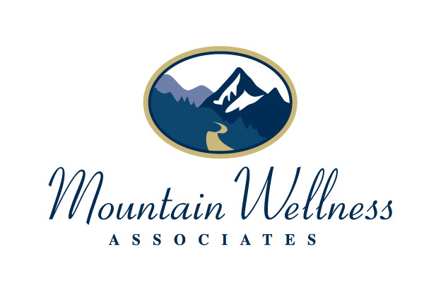
Office Safety Precautions in Effect During the Covid19 Pandemic

MWA is taking the following precautions to protect our clients, staff and the community during this time of public health crisis.

- Office seating in the reception area has been arranged for appropriate physical distancing.
- Restrooms and reception areas are cleaned/disinfected episodically throughout the day. Individual clients are free to use hand sanitizer and/or disinfectant wipes outside the bathroom as needed.
- Hand sanitizer that contains at least 60% alcohol is available in your provider’s individual office space.
- We schedule in-person appointments at specific intervals to minimize the number of people in the waiting room.
- We ask all clients to wait in their cars or outside until no earlier than 5 minutes before their appointment times and wear masks upon entering the building. If you do not have one, there are masks available in the reception area. The use of face masks in your individual providers offices is determined by state regulations, as well as you and your provider, based upon the office space’s ability to maintain adequate social distancing and/or air ventilation.
- Credit card pads, pens and other areas that are commonly touched are thoroughly sanitized throughout the day.
- Physical contact is not permitted.
- Tissues and trash bins are easily accessed. Trash is disposed of on a frequent basis.
- Common areas are thoroughly disinfected at the end of each day.
- MWA staff will be doing a daily health and safety check and documenting in our records.

